Evaluation Metrics and KNN
  - Colour notes with diagrams, formulas, code, and original screenshots
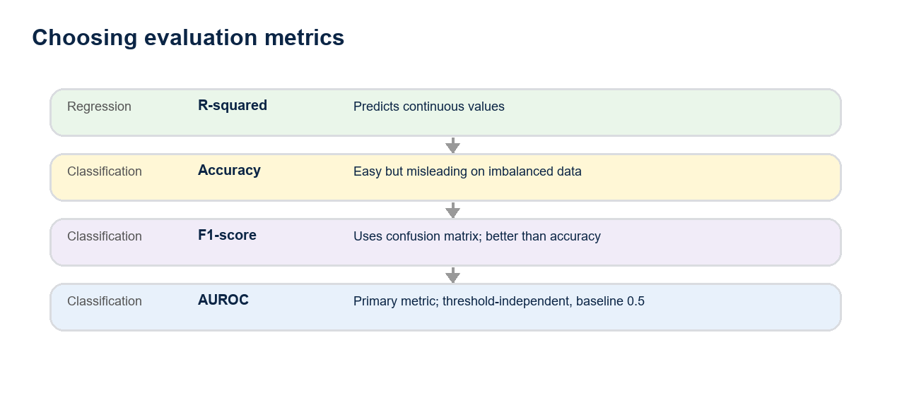
Big picture: choose metrics by the problem type, not by the model.
Main takeaway: For classification, use AUROC as the primary comparison metric. Accuracy can be misleading on imbalanced datasets; F1-score improves on accuracy by using the confusion matrix, but AUROC gives a stronger threshold-independent view.

1. Classification Evaluation Metrics
- A classification problem predicts a categorical target variable, for example whether a person is admitted or not admitted.
- Accuracy is the easiest metric, but it has many problems. It can be completely misguided for imbalanced datasets.
- F1-score improves on accuracy because it is built from confusion-matrix values.
- AUROC means Area Under the Receiver Operating Characteristic curve. It is the go-to metric for classification model comparison.
- For regression problems, the go-to evaluation metric is R-squared.

Metric Comparison
Metric | Problem Type | What it uses | Study note
Accuracy | Classification | Correct predictions / total | Easy to compute, but unreliable on imbalanced data.
F1-score | Classification | Precision and recall from the confusion matrix | Better than accuracy when positives and negatives are uneven.
AUROC | Classification | TPR and FPR across many thresholds | Best primary metric here; higher is better; 0.5 is baseline, 1 is max.
R-squared | Regression | Variation explained by model | Use for continuous target values.

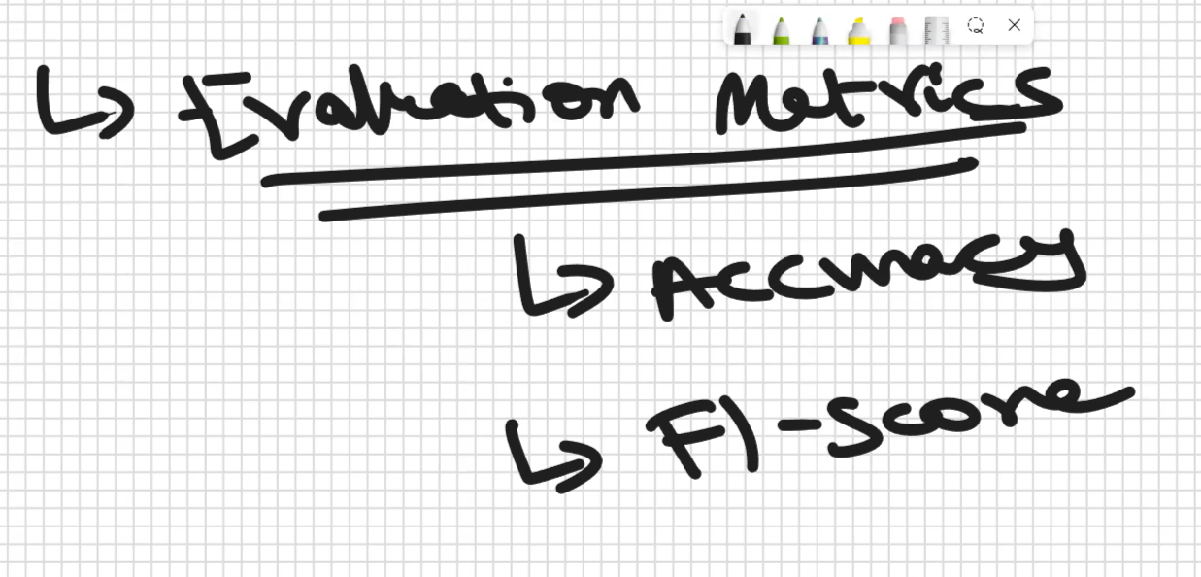

2. Confusion Matrix
To understand ROC and AUROC, first understand the confusion matrix. The model predicts probabilities, then a threshold converts those probabilities into predicted classes. With a threshold of 0.5, values above 0.5 become class 1 and values below 0.5 become class 0.
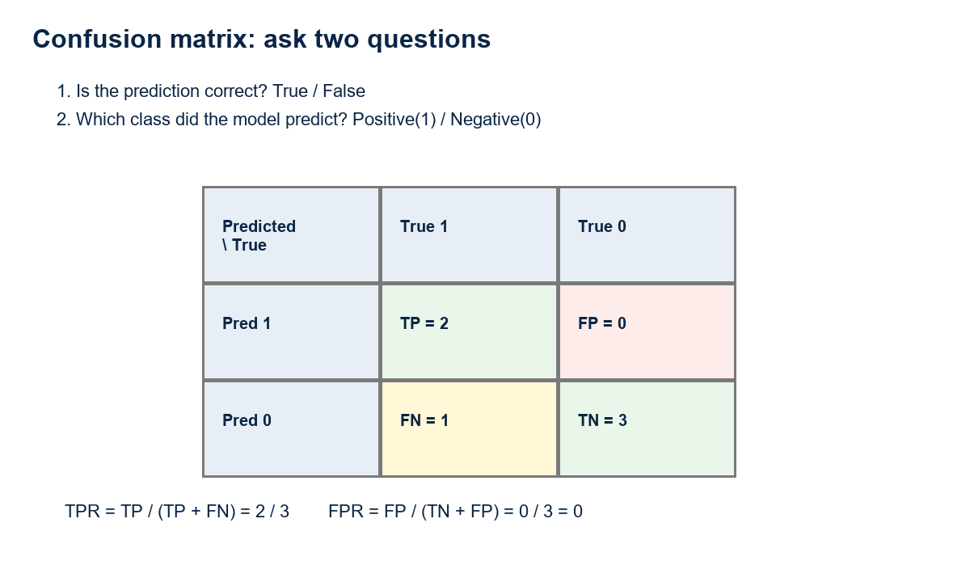
Confusion matrix terms from the worked example in the source notes.
Two-question rule: First ask whether the prediction is correct. Correct means True; wrong means False. Then ask which class was predicted: class 1 is Positive, class 0 is Negative.
- Predicting 1 when the true value is 1 gives True Positive (TP). In the example, TP = 2.
- Predicting 1 when the true value is 0 gives False Positive (FP). In the example, FP = 0.
- Predicting 0 when the true value is 1 gives False Negative (FN). In the example, FN = 1.
- Predicting 0 when the true value is 0 gives True Negative (TN). In the example, TN = 3.

TPR and FPR Formulas
Rate | Formula | Example value
TPR / Recall | TP / (TP + FN) | 2 / (2 + 1) = 2/3
FPR | FP / (TN + FP) | 0 / (3 + 0) = 0

3. ROC Curve and AUROC
ROC stands for Receiver Operating Characteristic. The ROC plot puts FPR on the x-axis and TPR on the y-axis.
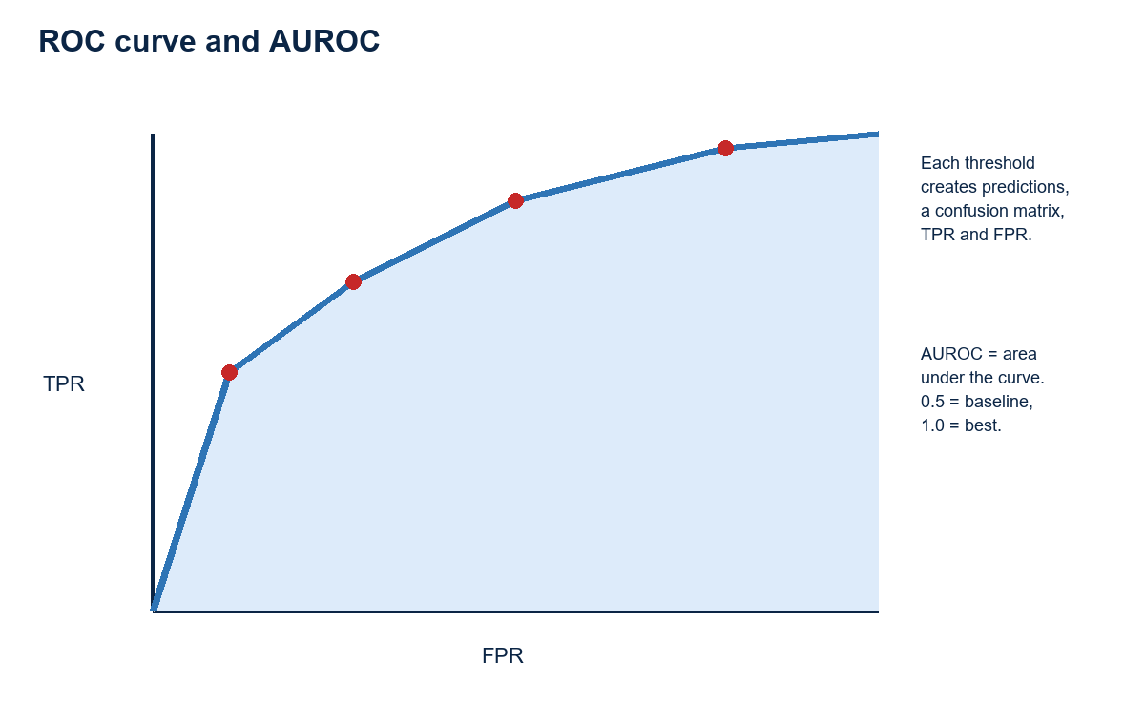
ROC is created by computing TPR and FPR for many threshold values.
- One threshold gives one predicted-class set, one confusion matrix, one TPR value, and one FPR value.
- For threshold 0.5, the example point is FPR = 0 and TPR = 2/3.
- A graph needs multiple points, so ROC varies the threshold, for example 0.1, 0.3, 0.4, 0.5, and so on.
- For threshold 0.3, predicted probabilities such as 0.8, 0.6, 0.45, and 0.3 become class 1, while 0.2 becomes class 0.
- For each threshold, predictions change, the confusion matrix changes, and the TPR/FPR point changes.
- AUROC is the area under the ROC curve. It ranges between 0 and 1.
- AUROC = 1 is best. AUROC = 0.5 is baseline. AUROC below 0.5 is considered useless in these notes.
- Higher AUROC means a better classification model. If two models are compared and M1 has the higher AUROC, M1 is better.
- When calling AUROC code, we do not manually specify a threshold because the ROC/AUROC calculation automatically considers thresholds between 0 and 1.
Why AUROC helps: AUROC is less biased by one fixed threshold. It evaluates how the model behaves across many thresholds, so it gives more confidence than accuracy and is easier to compare than F1-score.

4. Code Notes for Evaluation Metrics
Source code path mentioned in the original notes: D:\Koushik Sir ML\SecFri SS\logistic_regression(m1).py
Task | Code / syntax | Meaning
Import metrics | from sklearn.metrics import roc_curve, f1_score, confusion_matrix | Import evaluation helpers.
Accuracy | model.score(X_test, y_test) | Features plus target from the test dataset.
Confusion matrix | confusion_matrix(y_test, y_pred) | Compares true labels and predicted labels.
F1-score | f1_score(y_test, y_pred) | Computes F1 from y_test and y_pred.
ROC / AUROC plot | plot_roc_curve(logistic_regression, X_test, y_test) | Uses model, test features, and test target; gives graph and AUROC value.
- An accuracy value such as 0.8 is not automatically good because accuracy has no reliable baseline for imbalanced data. In contrast, AUROC of 0.8 is considered very good in these notes.
- The sample AUROC value mentioned is 0.88, considered a very good AUROC score.
- Evaluation metrics are problem-dependent, not model-dependent: classification uses accuracy, F1-score, and AUROC; regression uses R-squared.
- The same evaluation metric idea applies whether the model is linear regression, logistic regression, decision tree, random forest, or another model.
- Every model can produce a different AUROC graph. The shape itself is not the focus; the AUROC value is the comparison number.
- In the admission problem, GMAT, GPA, and work experience are features; admitted is the target variable.
- Dimensionality reduction means combining two features into one.

5. Supervised Learning Tasks and Models
- Supervised learning has two main task types: classification and regression.
- Unsupervised learning is a separate category.
- In linear regression, the model is y = mx + c. Here x is the feature and y is the target.
- Linear regression is an ML algorithm for regression problems.
- Logistic regression is an ML algorithm for classification problems.
- Different ML models have different mathematical formulas; those formulas are the models.

6. K-Nearest Neighbors (KNN)
KNN is an intuitive supervised learning model used for both classification and regression. These notes focus on the classification part first.
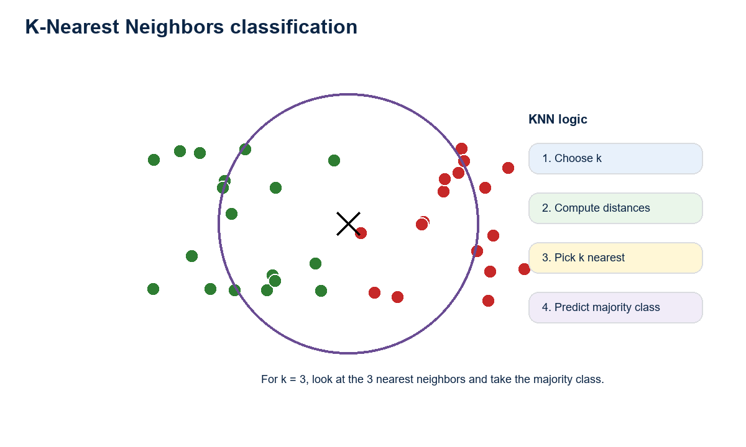
KNN predicts a new point by checking nearby training points.
- Logistic regression can struggle when there is no straight linear decision boundary between classes.
- In a non-linear class pattern, a human can often look at a black x test point and say it belongs near the green or red class.
- For a machine to do the same, it needs a formula for nearness. KNN measures nearness using distance.

KNN Classification Steps
- Get the k value from the data scientist, such as 1, 2, 3, or 4.
- Compute the distance between data points.
- Choose the k nearest neighbors.
- Predict the majority class among those neighbors.
Example with k = 3: If the three nearest neighbors are two green points and one red point, the prediction is green because green is the majority class.
- KNN only looks at the k nearest neighbors and the majority class.
- Outliers can make KNN predictions tricky because they are extreme values. Even if x is closest to a red point, k = 3 may still predict green if the other two nearest points are green.
- K can take values from 1 to infinity.
- For binary classification, even values of k are usually avoided because they can create ties between the two classes.
- Outliers can be detected using IQR, the interquartile range.

7. Parameters, Hyperparameters, and Best k
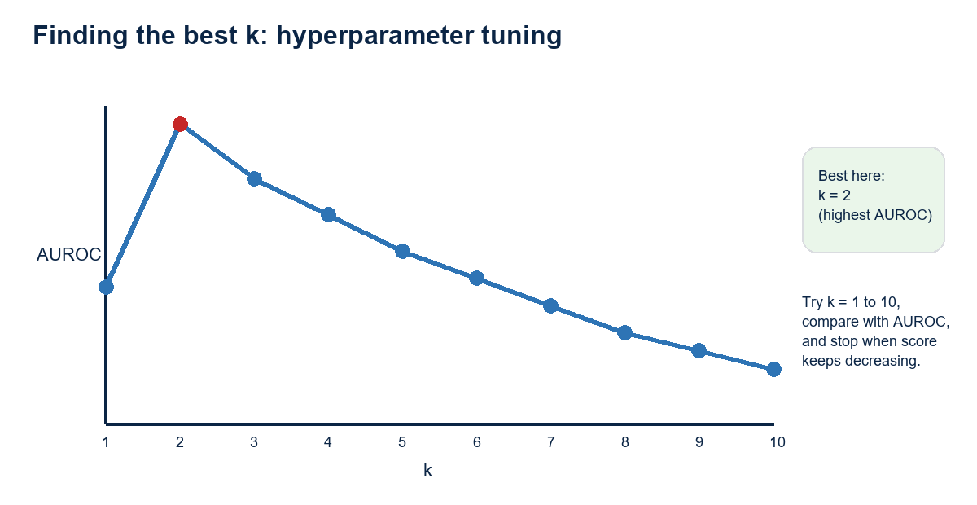
Try several k values and choose the model with the best AUROC.
- KNN does not automatically find k. The data scientist gives k to the model.
- Values that the data scientist gives to a model are called hyperparameters. In KNN, k is a hyperparameter.
- In linear regression y = mx + c, the algorithm learns m and c automatically. Those learned values are parameters.
- Values the algorithm finds automatically are parameters; values we feed into the model are hyperparameters.
- Hyperparameter tuning means finding the best value of a hyperparameter.
- For KNN, use hit and trial: build 1NN, 2NN, 3NN, and so on, usually trying k from 1 to 10.
- Compare those models using AUROC because this is a classification problem.
- In the example, k = 2 is the best value because it gives the best AUROC score.
- After a certain point, if the model score keeps decreasing, that is a sign to stop increasing k.

8. Scaling and Lazy-Learning Notes
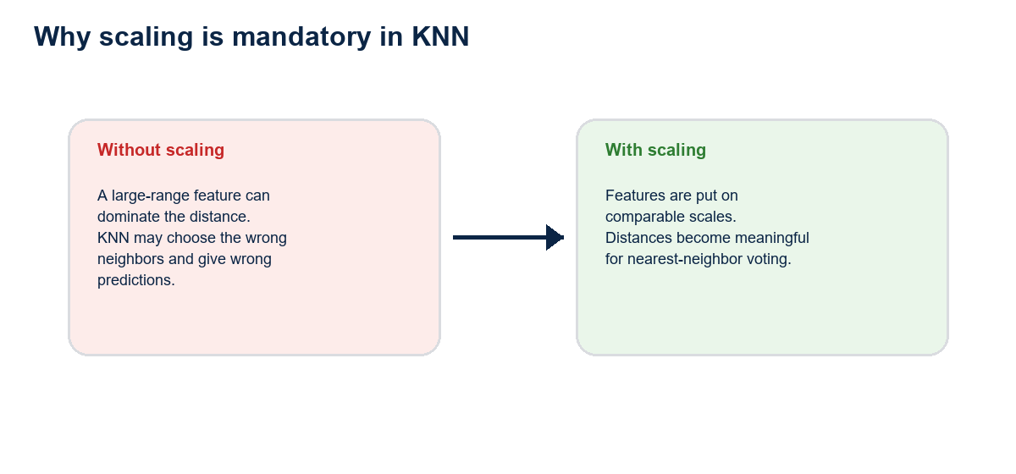
Because KNN is distance-based, feature scaling is not optional.
- Scaling is a mandatory step in KNN.
- Whenever distance metrics are computed, scaling is mandatory.
- If KNN is trained or fitted without scaling, it can give completely wrong answers.
- KNN has no learned parameters, so there is no loss function in the usual parameter-learning sense.
- KNN is called a lazy algorithm because it has no parameters and no loss-function learning requirement.
- It is still debated whether KNN should be called a machine-learning algorithm because there is no learning in the parameter-fitting sense, but it is still an important algorithm.
- For every test point x, if k = 3, the model finds the three nearest neighbors from that test point.
- KNN is used for both regression and classification. These notes covered classification first; regression comes next.

9. Quick Revision Sheet
Question | Answer
Best metric for classification? | AUROC.
Best metric for regression? | R-squared.
Why is accuracy risky? | It can mislead on imbalanced datasets and lacks a useful baseline.
What is AUROC baseline? | 0.5. Higher is better; 1 is best.
What creates ROC points? | Different thresholds create different predictions, confusion matrices, TPR, and FPR.
What is TPR? | TP / (TP + FN).
What is FPR? | FP / (TN + FP).
What does KNN need from the data scientist? | The k hyperparameter.
How do we choose k? | Try values, compare AUROC, and keep the best.
Why scale before KNN? | Distance calculations only make sense when features are on comparable scales.

10. Original Screenshots from Source Document
The original document contained the following embedded screenshots/images. They are preserved here as a gallery so the redesigned notes still cover the visual material from the source.

